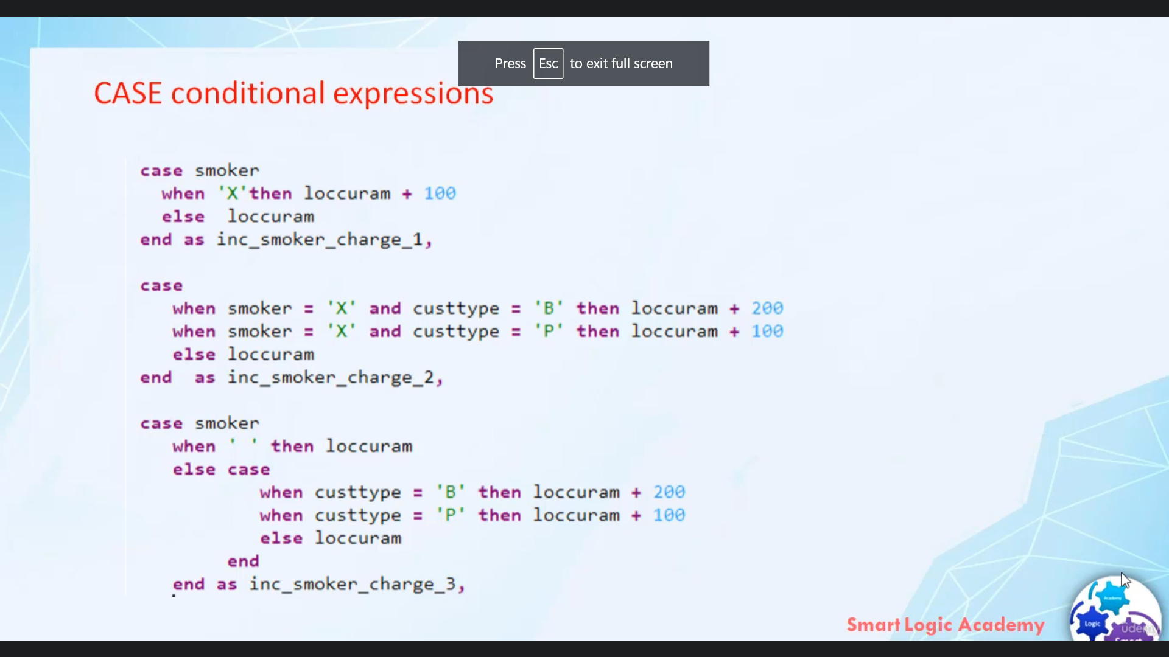

Hi, welcome back.

In this video, I will discuss with you about these conditional expressions in the services as of releasing

one for the speed of openness, could support the use of conditional expressions of absurdities of a

gas explosion that can be used in Elementalist.

Absolute statement.

Gas explosions always start with killer case, an individual in an gas explosion always returns exactly

one value for every case explosion, you have to assign one.

Is this a mandatory condition?

Statement of the when clause is a condition and the statement of the Dean clause is the result, if

the condition in when clause is not true, then the part of any statement we get executed.

If this branch is missing, then the thing that it will issue a warning here, the first case expression

that is there depends on the value of the operands will be operated smoker.

This inculcates expression is comparable to the statement in about second guess expression here.

The desert depend on sequence of logical expressions.

Here you can see there is no option in case expression.

So such kind of case expressions is comparable to if statement in about the third expression shows that

we can use nested statements.

This is all about detainee now.

Let's quickly design one where we can use this case conditioner expeditions.